4.5 Worksheet

- Find the intervals on which is increasing, decreasing, and local extrema.

We calculate: .

when

is never undefined.
$$0$$
$$-1$$
$$2$$
$$-$$
$$+$$
$$-$$
$$+$$
$$MAX$$
$$MIN$$
$$MIN$$

Increasing/Decreasing  Increasing on:  Decreasing on: | Local Minimums & Maximums  Local minimum:  Local maximum:

- Suppose the function f has the first derivative of .
List each interval upon which the function f is increasing and decreasing. State the value of x at which any local maximums or minimums of f occur.
The critical numbers are
$$3$$
$$+$$
$$\frac{1}{2}$$
$$-8$$
$$8$$
$$-$$
$$+$$
$$-$$
$$-$$
$$MAX$$
$$MIN$$
$$MIN$$

Increasing on:  Decreasing on: | Local Maximum(s) occur(s) at:  Local Minimum(s) occur(s) at:
- Find all intervals on which is concave up and down. Find all inflection points on the graph of f.

We calculate that:
when

is never undefined.
$$0$$
$$-$$
$$+$$
$$+$$
$$1$$

Concavity:  Concave up on:  Concave down on: | Inflection Points:

- Find the critical numbers of .

We calculate
when

is undefined when .
The critical numbers are therefore

- Suppose that is a function whose first derivative is .
Find all critical numbers of . At each critical number, state whether has a local maximum, local minimum or neither at that point.

The critical numbers are
$$4$$
$$-5$$
$$5$$
$$+$$
$$-$$
$$-$$
$$+$$
$$MAX$$
$$MIN$$

Increasing on:  Decreasing on: | Local Maximum(s) occur(s) at:  Local Minimum(s) occur(s) at:

- A polynomial has the second derivative . State the interval where f is concave up and concave down. State each x-value at which the graph of has an inflection point.

when
is never undefined.
$$-7$$
$$-14$$
$$0$$
$$-$$
$$+$$
$$+$$
$$-$$
$$14$$
$$+$$

Concavity:  Concave up on:  Concave down on: | Inflection Points:  Occur at

- Find each interval of concavity and each inflection point for the function .
We calculate:
Therefore,

when .
is undefined when .
$$0$$
$$+$$
$$-$$
$$+$$
$$10$$

Concavity:  Concave up on:  Concave down on: | Inflection Points:  Occur at .  So we have the point:  Note that is not in the domain of f so it cannot be a point of inflection.

- Find when the function is increasing, decreasing, concave up, and concave down. Also find all relative extrema and inflection points of .
$$1/3$$
$$+$$
$$-$$
$$MAX$$
We calculate:
when . is never undefined.

Increasing/Decreasing  Increasing on:  Decreasing on: | Local Minimums & Maximums  Local minimum: None  Local maximum:
We calculate:
$$2/3$$
$$-$$
$$+$$
when . is never undefined.

Concavity:  Concave up on:  Concave down on: | Inflection Points:
- A bullet is fired upwards from the ground at an initial velocity of 1200 feet per second. The height s (in feet) of the bullet above the ground after t seconds is on Mars and on Earth. How much higher will the bullet travel on Mars than on Earth? (Hint: What is the slope of the tangent line when the bullet is at it highest point?)

Height on Mars:
The maximum height is reached when the velocity is zero.
We compute the height at this time:

Height on Earth:
The maximum height is reached when the velocity is zero.
We compute the height at this time:

Note that
Therefore the bullet will travel higher on Mars than on Earth.

- A rock is thrown upward from the surface of the moon. Between the time that the rock is thrown and the time that the rock hits the ground, the rock’s height is given by the formula , where t is the number of seconds since the rock is first thrown and is measured in meters above the moon’s surface.
- Find a formula for the rock’s velocity at time t.

- Find a formula for the rock’s acceleration at time t.

- How fast was the rock moving, and in which direction, at the end of 25 seconds.

The rock is moving downward at a velocity of 16m/s at the end of 25 seconds.

- What is rock’s maximum height and at what time does it reach that height?

When the rock obtains its maximum height its velocity is 0 m/s.
The rock reaches a maximum height of 180m after 15 seconds.
- Sketch a graph of the curve .

We calculate:
when . is never undefined.
$$0$$
$$-3$$
$$3$$
$$+$$
$$-$$
$$-$$
$$+$$
$$MAX$$
$$MIN$$

Increasing/Decreasing  Increasing on:  Decreasing on: | Local Minimums & Maximums  Local minimum:  Local maximum:
We calculate:
when . is never undefined.
$$0$$
$$-\frac{3}{\sqrt{2}}$$
$$\frac{3}{\sqrt{2}}$$
$$-$$
$$+$$
$$-$$
$$+$$

Concavity:  Concave up on:  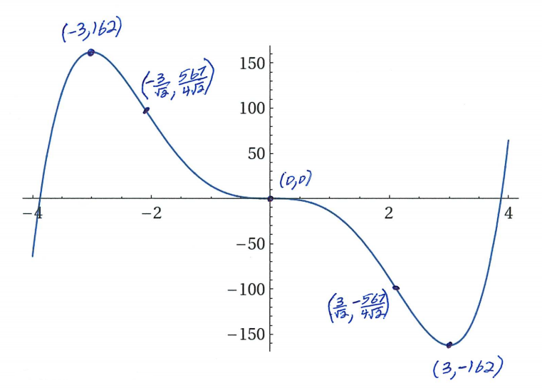  Concave down on: | Inflection Points:
- Find the absolute extrema of on the interval .
We are not looking at a closed interval so we cannot be sure has an absolute max. & min. on .
We calculate: .
Notice that is undefined when .
Notice that when .
Therefore the only critical numbers of the function in the interval is .
We also consider the limits as we approach the endpoints of this open interval.
Can avoid by considering
the number line
$$0$$
$$+$$
$$1$$
$$1/2$$
$$-$$
$$MAX$$
Therefore we see that has:
- NO absolute minimum
- an absolute maximum

- Find the absolute extrema of on the interval.

We are not looking at a closed interval so we cannot be sure has an absolute max. & min. on .
We calculate:

Notice that is never undefined.
Notice that when .
Therefore the only critical numbers of the function in the interval is .
We also consider the limits as we approach the endpoints of this open interval.

$$MIN$$
$$2$$
$$-$$
$$+$$
$$0$$
Can avoid by considering
the number line
Therefore we see that has:
- absolute minimum
- NO absolute maximum
- Determine the absolute minimum y-value on the graph of . Simplify your answer fully.

We calculate that .
Notice that is never undefined.
Notice that when:

Therefore the critical numbers of the function are .
$$MIN$$
$$\ln\left(3\right)$$
$$-$$
$$+$$
$$0$$

Therefore we see that has an absolute minimum .

- Determine the x-value at which the function attains its absolute maximum value.
We calculate that .

Notice that is never undefined.
Notice that when:

Therefore the critical numbers of the function are .
$$\ln\left(\sqrt{5}\right)$$
$$+$$
$$-$$
$$0$$
$$MAX$$

Therefore we see that has an absolute maximum

- What are the coordinates for the highest point on the graph of the function .

We calculate .
$$1/2$$
$$+$$
$$-$$
$$0$$
$$MAX$$
Notice that is never undefined.
Notice that when
Therefore the critical numbers of the function are .
Therefore we see that has an absolute maximum .

- Find the intervals where is increasing, decreasing, concave up, and concave down. Find all local extrema and inflection points of f.
$$-1$$
$$-$$
$$+$$
$$MIN$$
First Derivative:
when
is never undefined.

Increasing/Decreasing  Increasing on:  Decreasing on: | Local Extrema  Local minimum:  Local maximum: None

Second Derivative:
when
is never undefined.
$$-2$$
$$-$$
$$+$$

Concavity:  Concave up on:  Concave down on: | Inflection Points:

- Find the intervals where is increasing, decreasing, concave up and concave down on the interval . Find all the local extrema and inflection points of f.

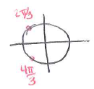
First Derivative:

when
is never undefined.
$$\frac{2π}{3}$$
$$+$$
$$-$$
$$+$$
$$MIN$$
$$MAX$$
$$\frac{4π}{3}$$

Increasing/Decreasing  Increasing on:  Decreasing on: | Local Minimums & Maximums  Local minimum:  Local maximum:

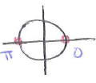
Second Derivative:

when
is never undefined.

$$0$$
$$-$$
$$2π$$
$$π$$
$$+$$

Concavity:  Concave up on:  Concave down on: | Inflection Points:

